

|  |
| --- |
| **SyneMobiSafe – Use Case Analysis**  Vishal Bhardwaj, Assistant Manager – Software |
|  |

Table of Contents

Introduction 3

SyneMobiSafe User Types 3

SyneMobiSafe Basic User Use Case 3

• Data Backup Operation 3

• Device Recovery Operations 3

• Device Security Operations 3

• Device Health Monitoring Operations 3

• KIA Operations 3

• Use Case Diagram (SyneMobiSafe Basic User) 4

SyneMobiSafe Premium User Use Case 4

• Tech Support and Live Chat Feature 4

• Telemetry Operations 4

• Use Case Diagram (SyneMobiSafe Premium User) 5

SyneMobiSafe System Use Case 5

• Description 5

• Basic User Role: 5

• Premium User Role 5

• Agent User Role 6

• Use Case Diagram (SyneMobiSafe System Use Case) 6

# Introduction

Use case analysis is one of the most important and valuable requirement analysis technique we can leverage for clarifying and documenting the functional requirements of the SyneMobiSafe. A use case is a list of actions or event steps, typically defining the interactions between a role (known in the Unified Modeling Language as an actor) and a system, to achieve a goal. This document contains various use cases to capture the SyneMobiSafe Module functionalities.

# SyneMobiSafe User Types

SyneMobiSafe is designed in such a way that it can support multiple user roles which can be extended as and when needed. The default implementation has 2 major roles-

* Basic User
* Premium User

# SyneMobiSafe Basic User Use Case

Basic user of the SyneMobiSafe should be able to perform following operations:

### Data Backup Operation

A basic user will be able to access the cloud data backup feature of SyneMobiSafe. The user will have the access to upload/restore all of his/her data(i.e. images/videos/contacts) to the cloud.

### Device Recovery Operations

A basic user will be able to perform all the recovery functions provided by SyneMobiSafe. So, this user will always have the access to lock/alarm/lock/wipe features of SyneMobiSafe.

### Device Security Operations

A basic user will have all the access to the device security features of SyneMobiSafe.

### Device Health Monitoring Operations

A basic user will have the access to device monitoring and scanning features of SyneMobiSafe, so, a user can perform any of these scan operations - speed, storage or battery.

### KIA Operations

A basic user will be able to use this knowledge based function of SyneMobiSafe. The user can also perform search functions.

### Use Case Diagram (SyneMobiSafe Basic User Use Case)

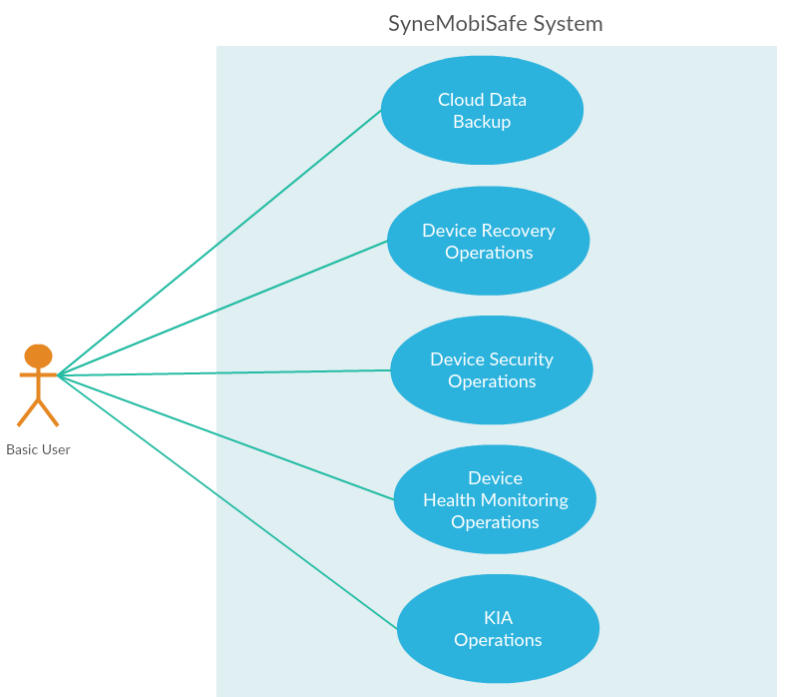

# SyneMobiSafe Premium User Use Case

Premium users has access to all the features provided by SyneMobiSafe. Apart from the operations entitled to basic users, a premium user should be able to perform following additional operations :

### Tech Support and Live Chat Feature

A premium user will also have access to the tech support feature provided by SyneMobiSafe. So, the user can perform chat and tech support operations.

### Telemetry Operations

A premium user can also access to the Telemetry operations provided by SyneMobiSafe.

### Use Case Diagram (SyneMobiSafe Premium User Use Case)

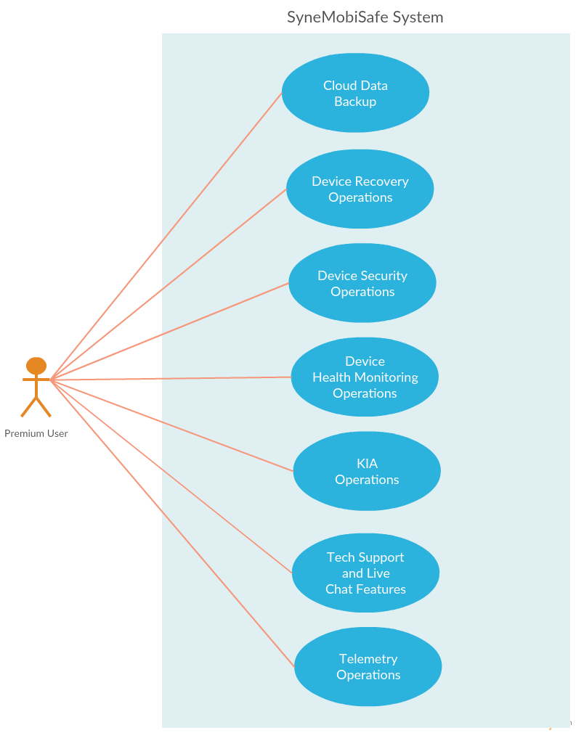

# SyneMobiSafe System Use Case

### Description

SyneMobiSafe system use case gives you an idea about role based use cases. Apart from the basic and premium users(device), there is another set of system users known as agents(web), who can provide tech support and generate KIA related content.

### Basic User Role:

Basic users have the access to a subset of features provided by SyneMobiSafe apart from Technical support & Live Chat feature and Telemetry Operations.

### Premium User Role:

Premium users can access all the features and functionalities provided by SyneMobiSafe.

### Agent User Role:

Agent users of the SyneMobiSafe should be able to perform different operations such as generate rich HTML content and save it on the remote repository for the search operation to be functional. They can also be tech agents providing support in solving user issues.

### Use Case Diagram (SyneMobiSafe System Use Case)

